**Day1**  
Java Programming Language

Java is an object-oriented language, which means that it is based on the concept of "objects" that represent data and the actions that can be performed on that data. Java also has several features that make it well-suited for building large, complex systems, including strong support for object-oriented programming, a rich set of libraries and frameworks, and a robust type system. It is designed to be simple, fast, and easy to learn.

One of the advantages of Java is that it is platform-independent, meaning that it can run on any device that has a Java Virtual Machine (JVM) installed. This means that a Java program can be written once and then run on any device, regardless of the operating system or hardware architecture.

Overall, Java is a powerful and popular programming language that is widely used for building a variety of applications.

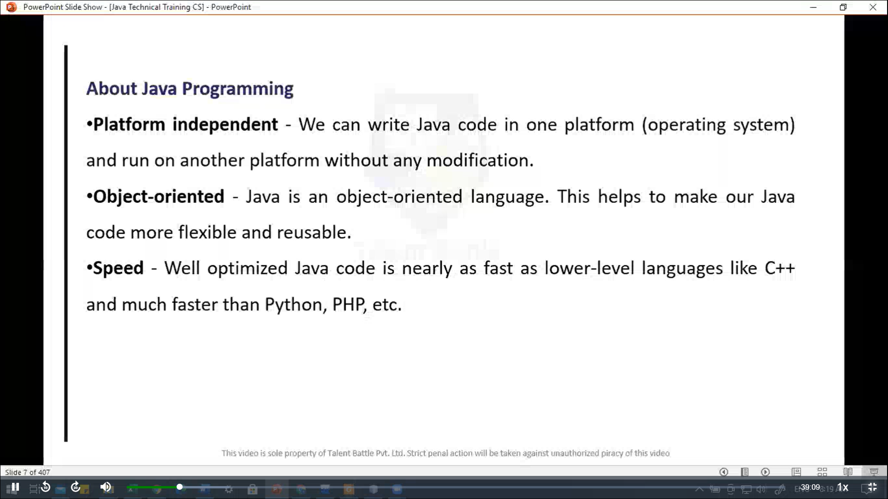

// Java Hello World Program

// Your first program

class HelloWorld {

  public static void *main*(String[] ***args***){

    System***.***out***.****println*("Hello, World!")***;***

  }

}

PS C:\Users\hp\Desktop\TCS IT\Java\Day1> javac .\HelloWorld.java

PS C:\Users\hp\Desktop\TCS IT\Java\Day1> java .\HelloWorld.java

Hello, World!

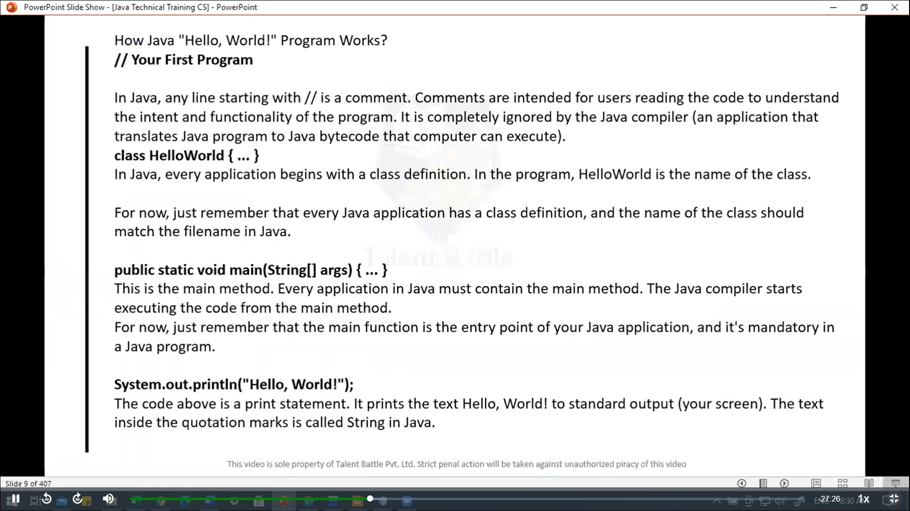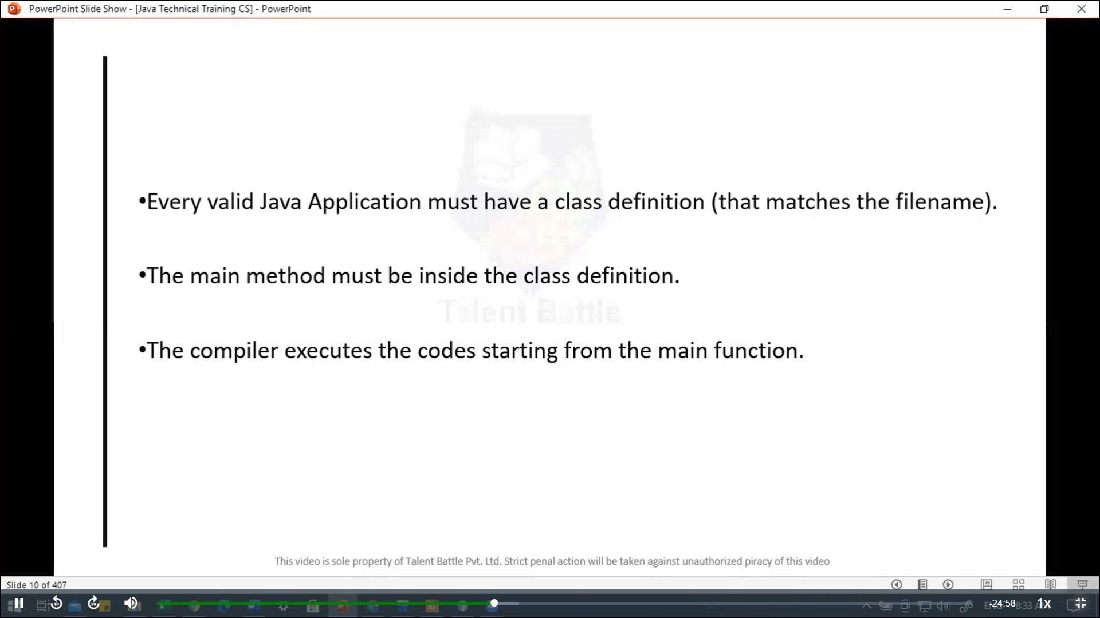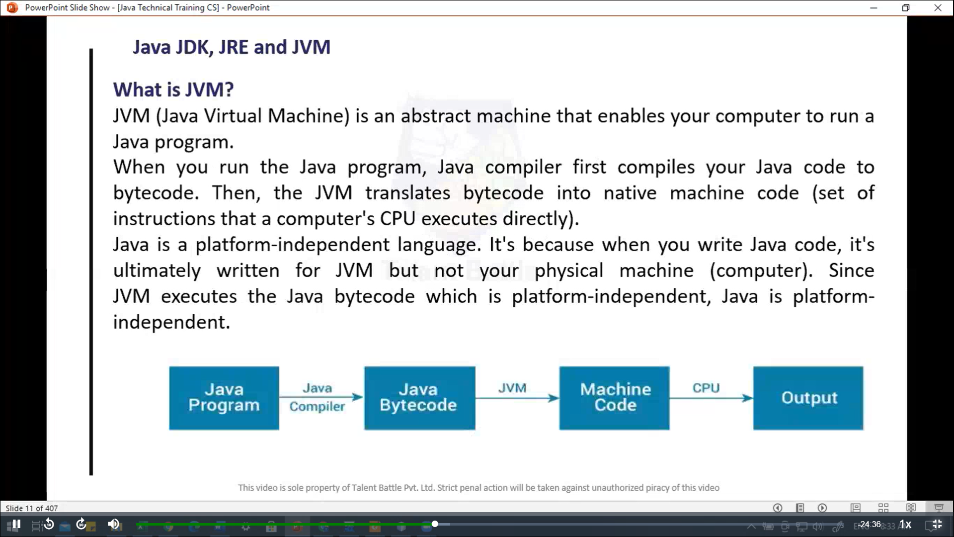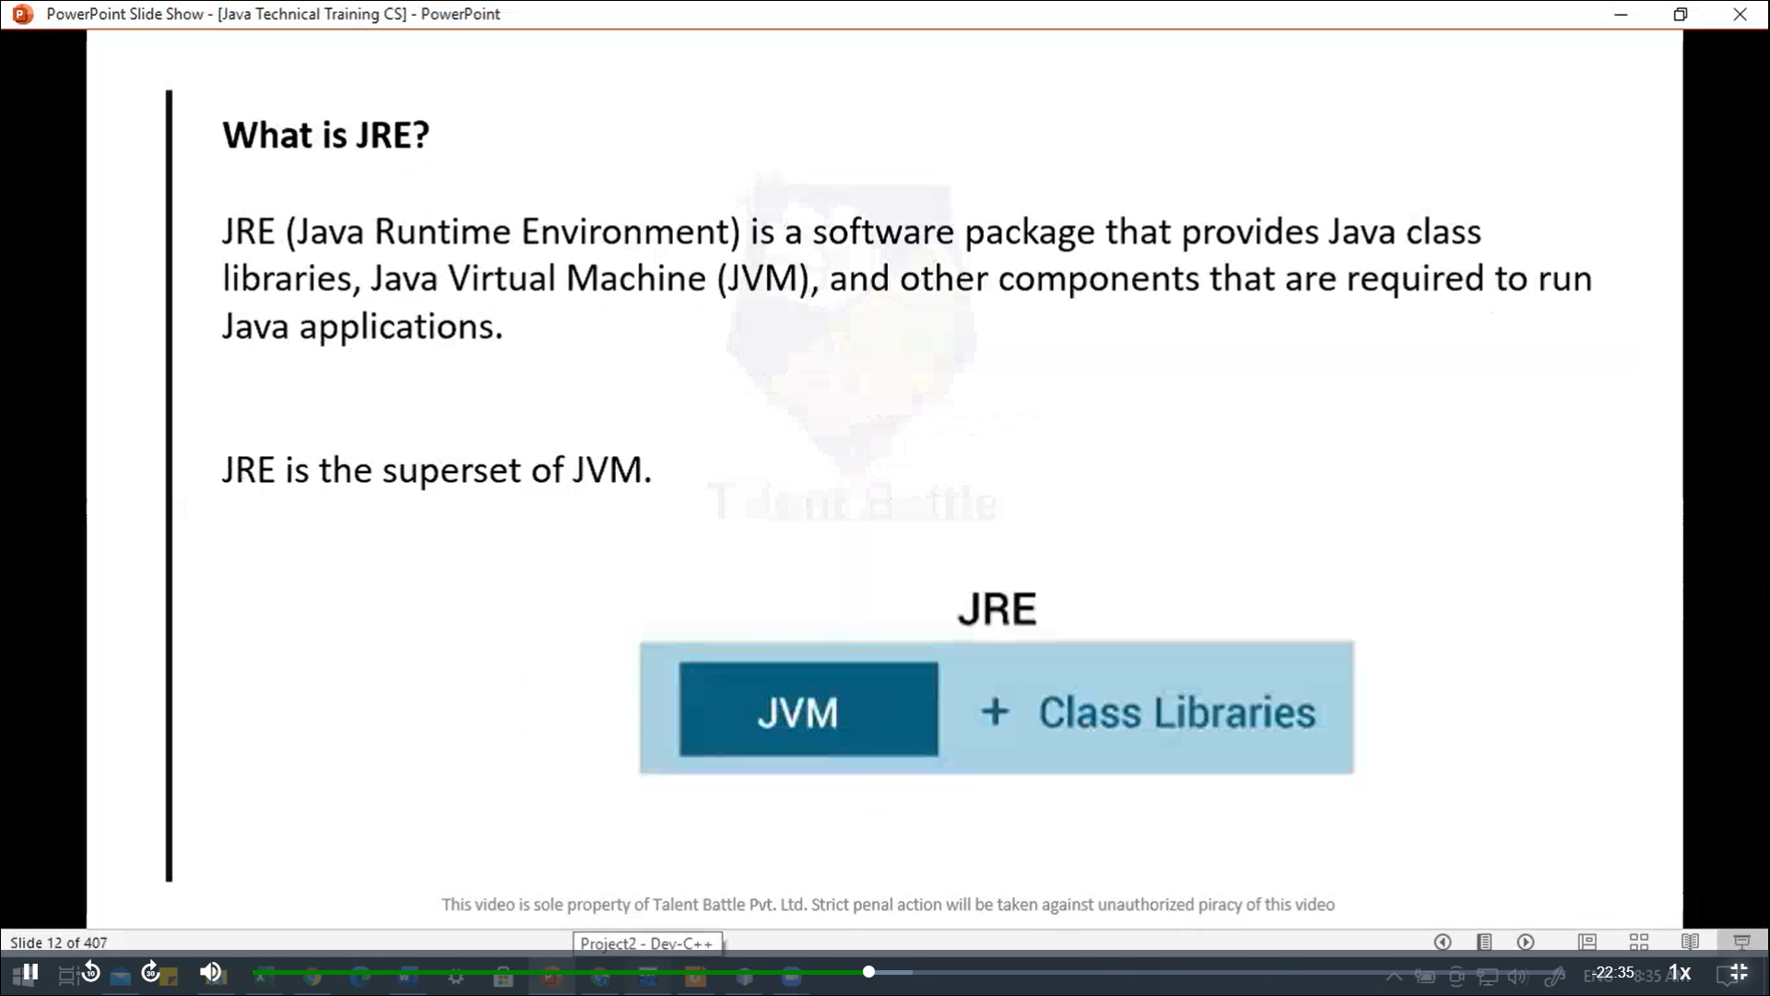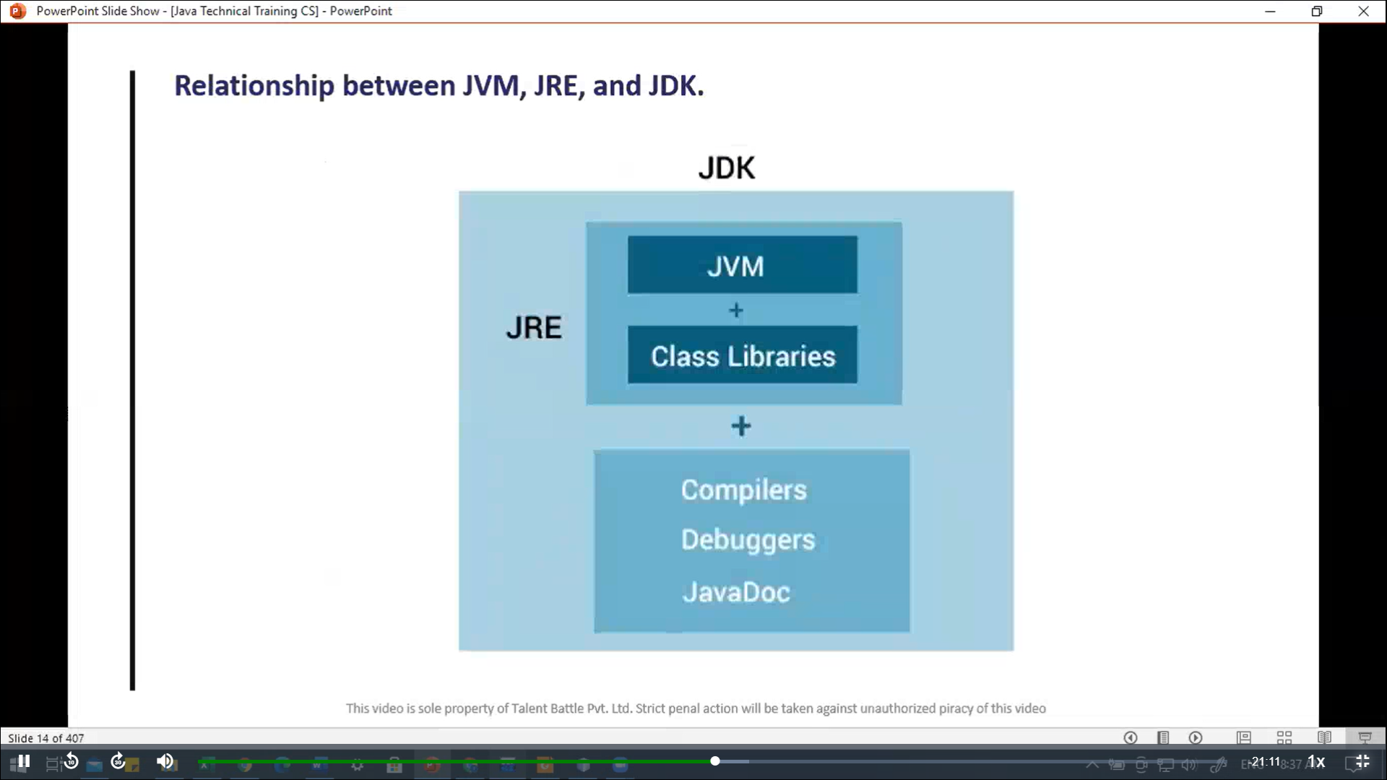 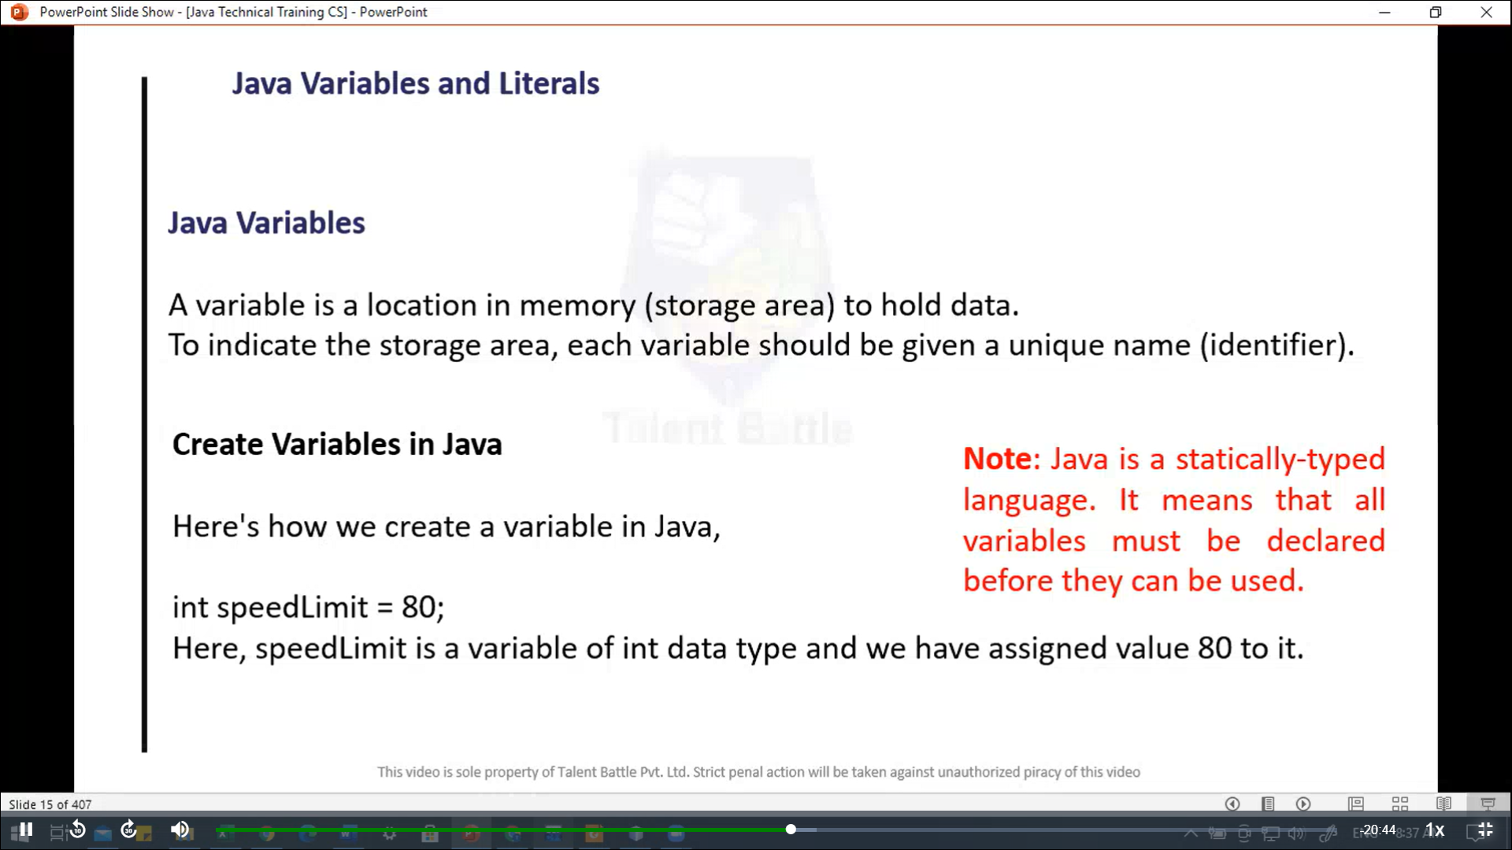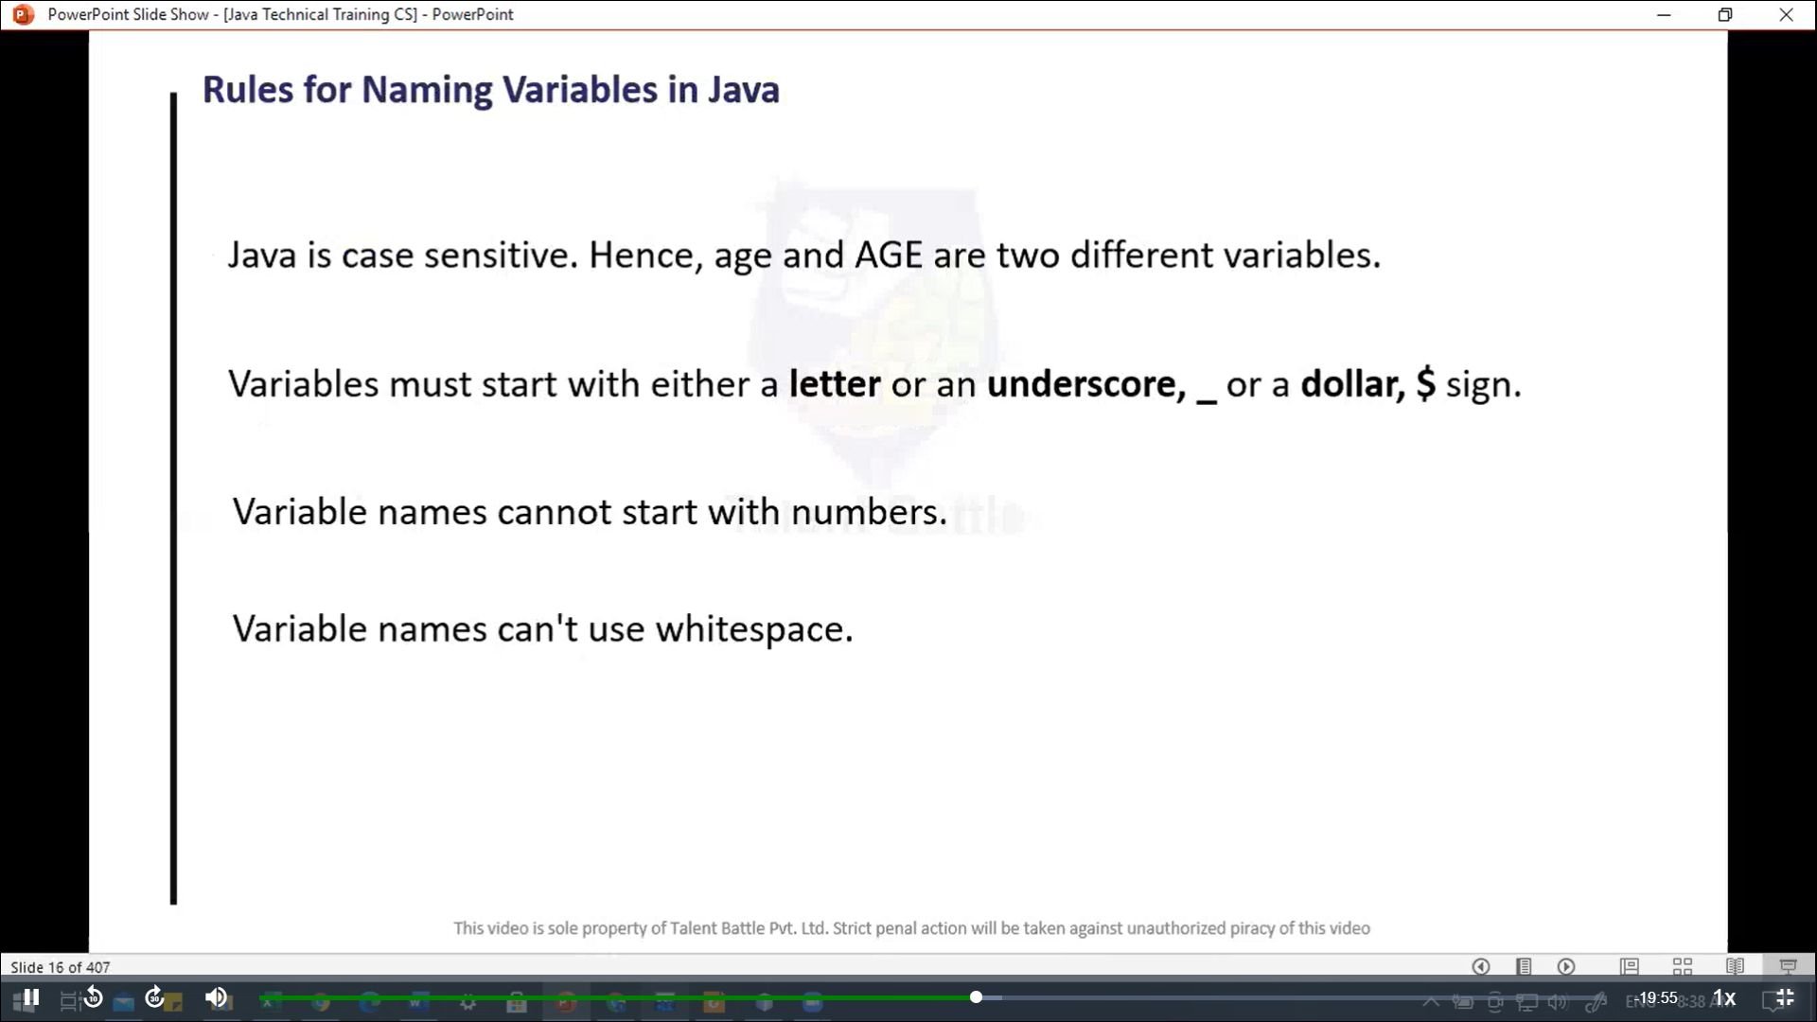

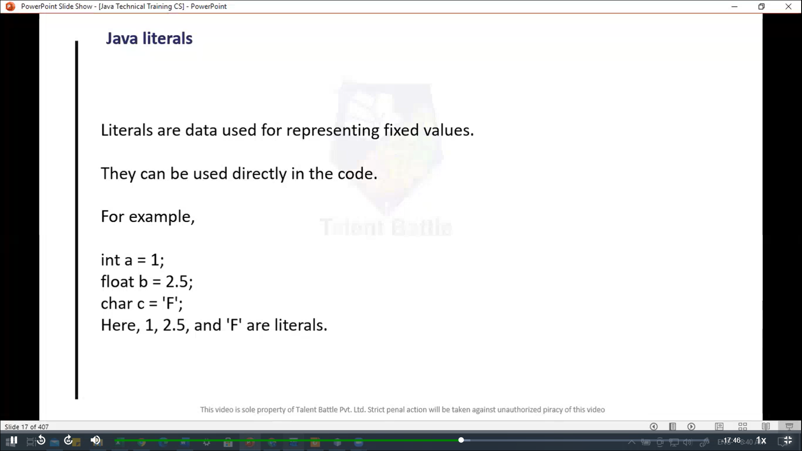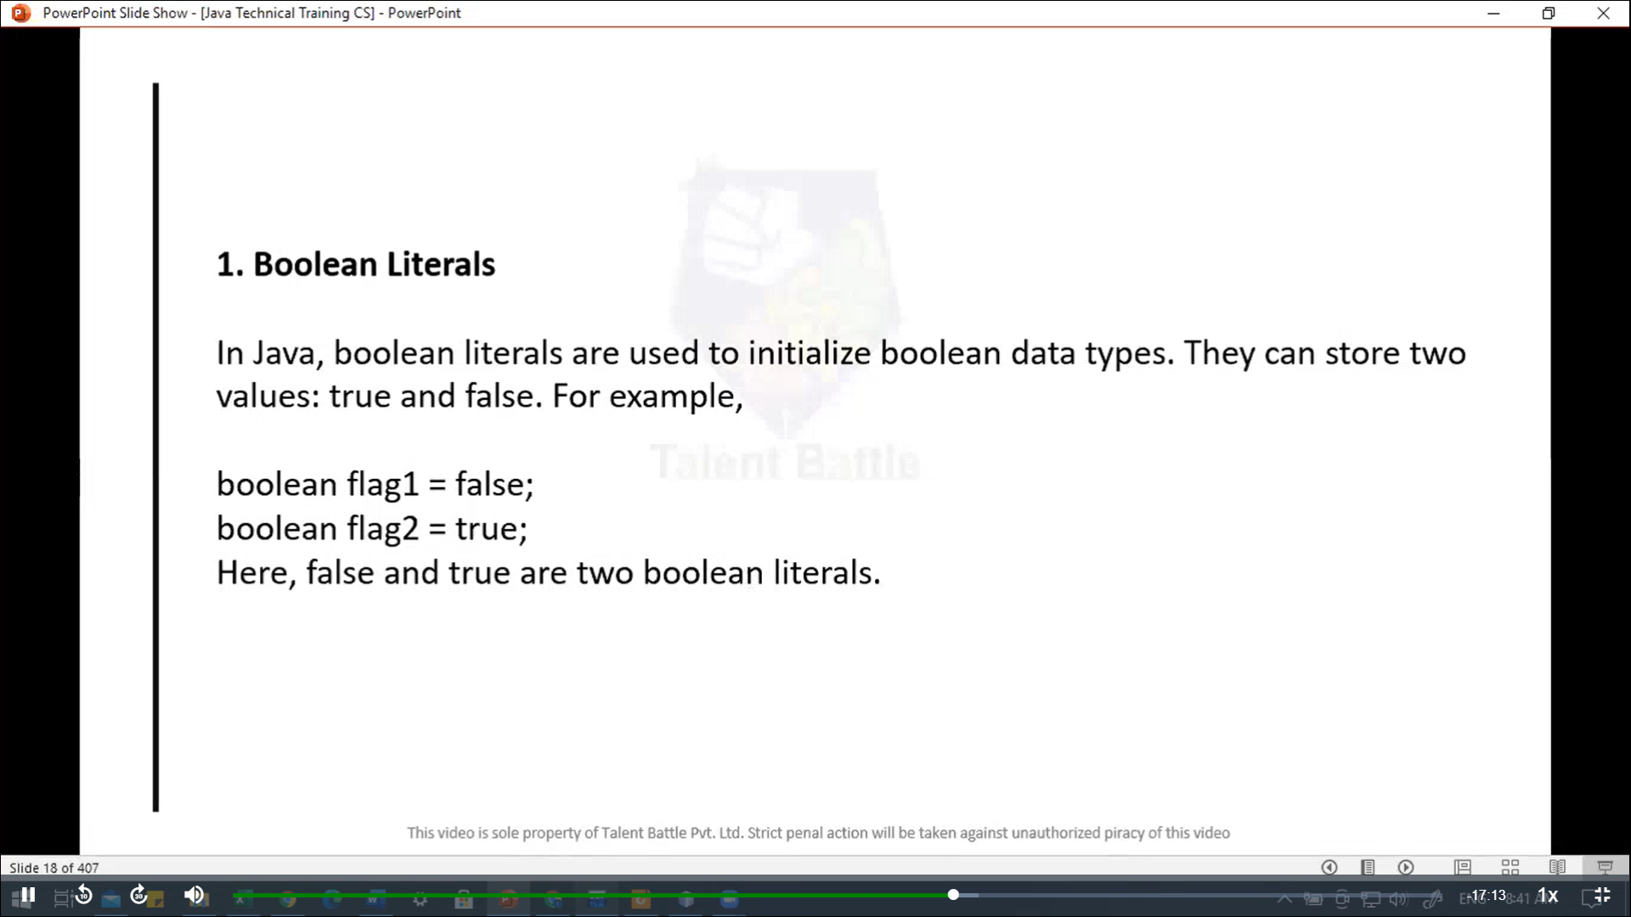

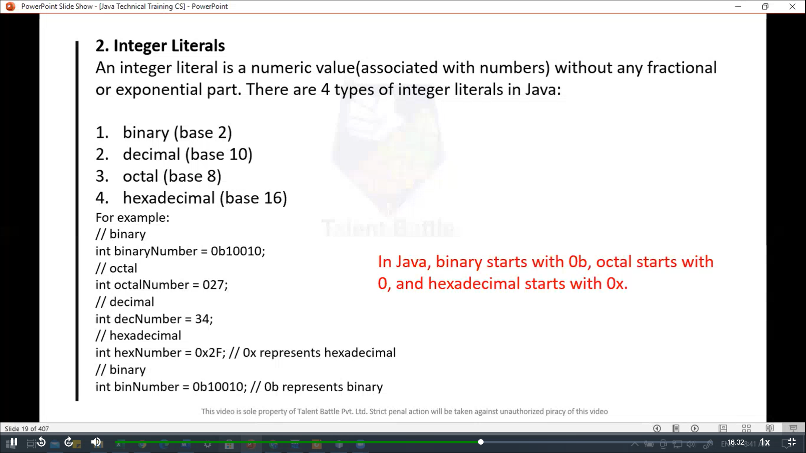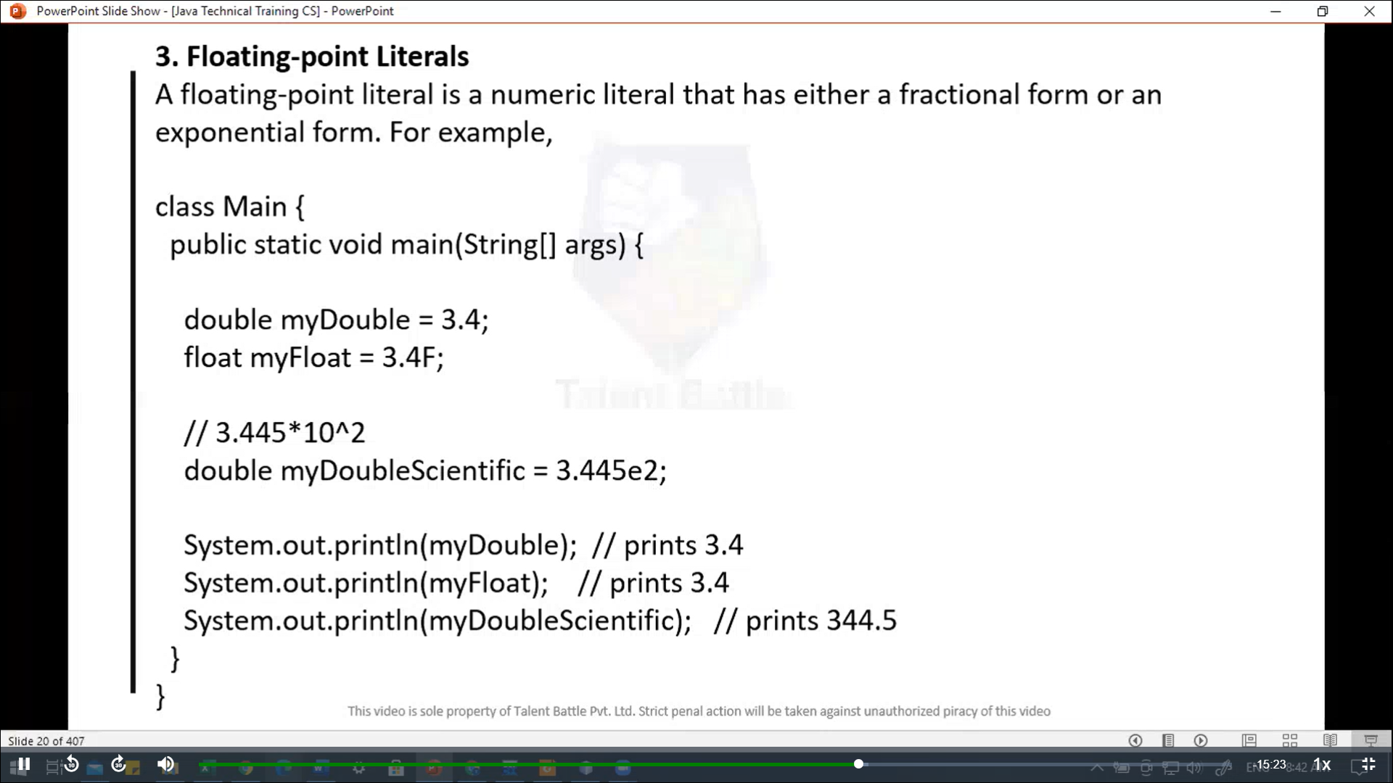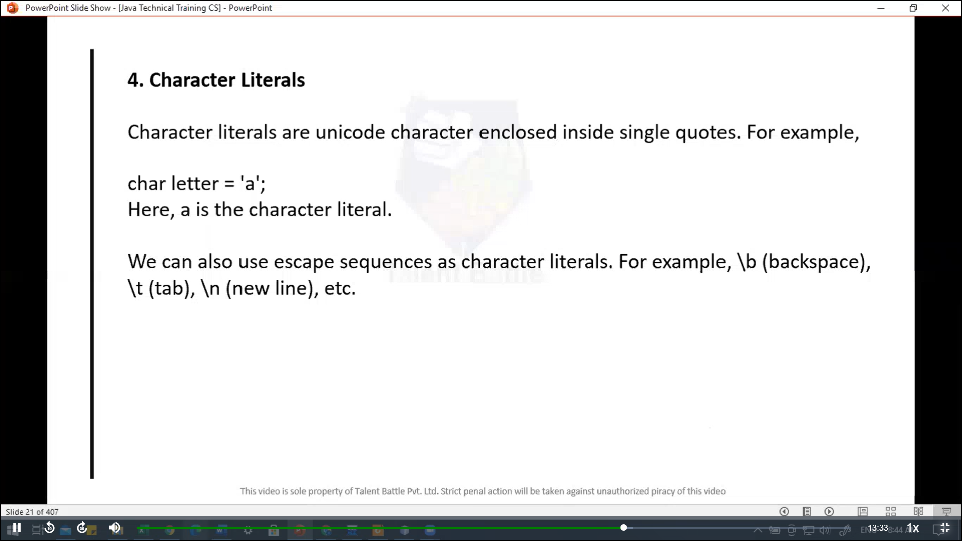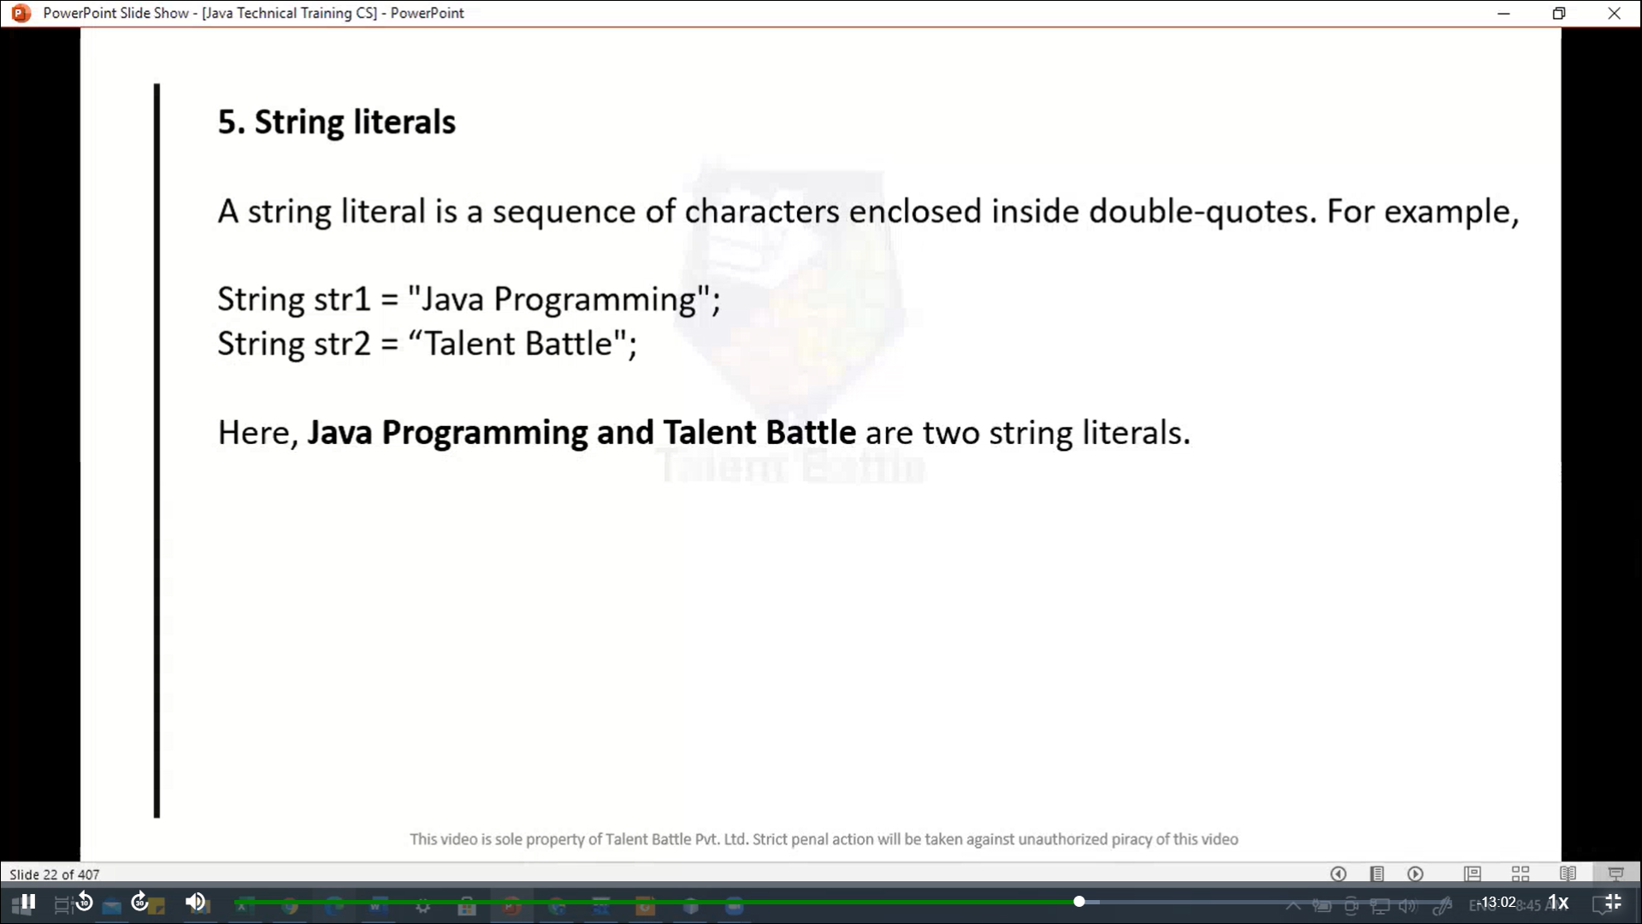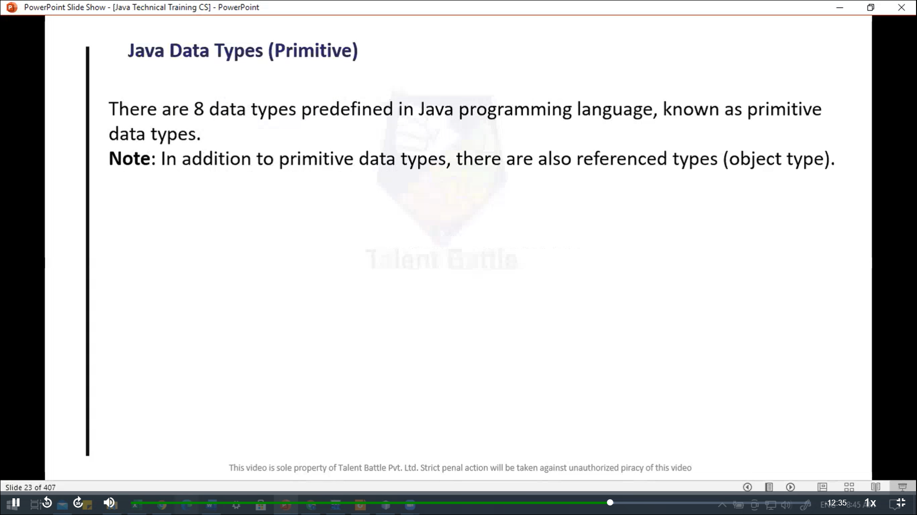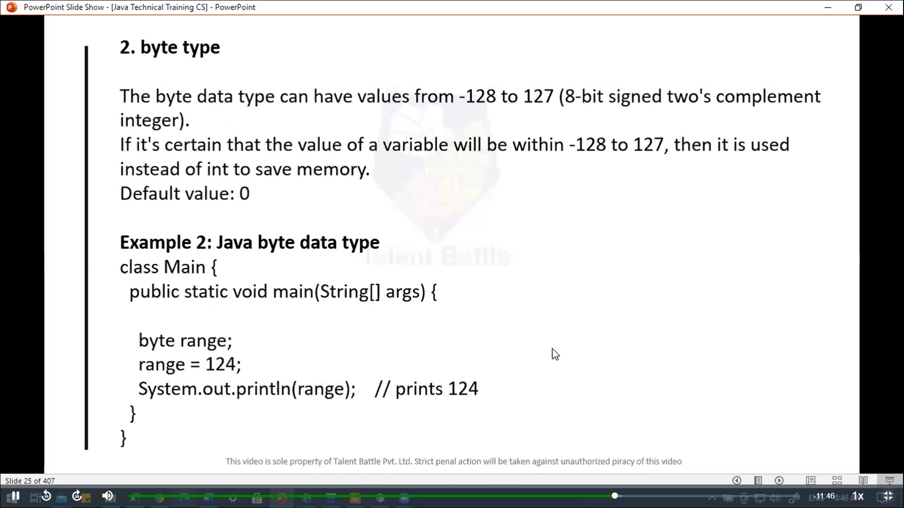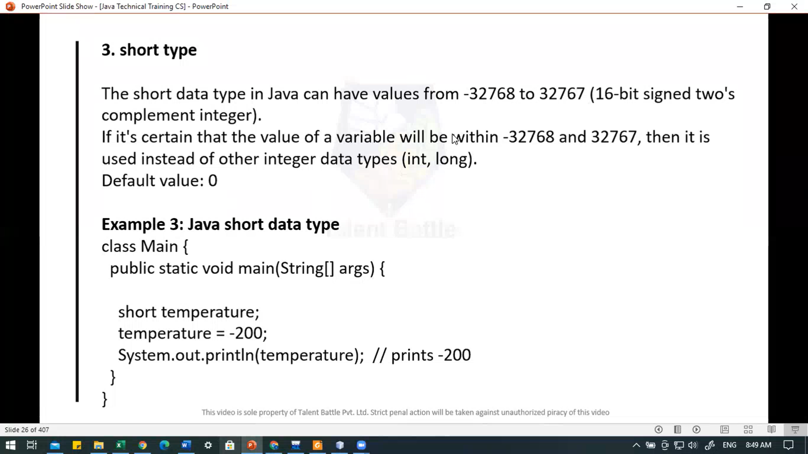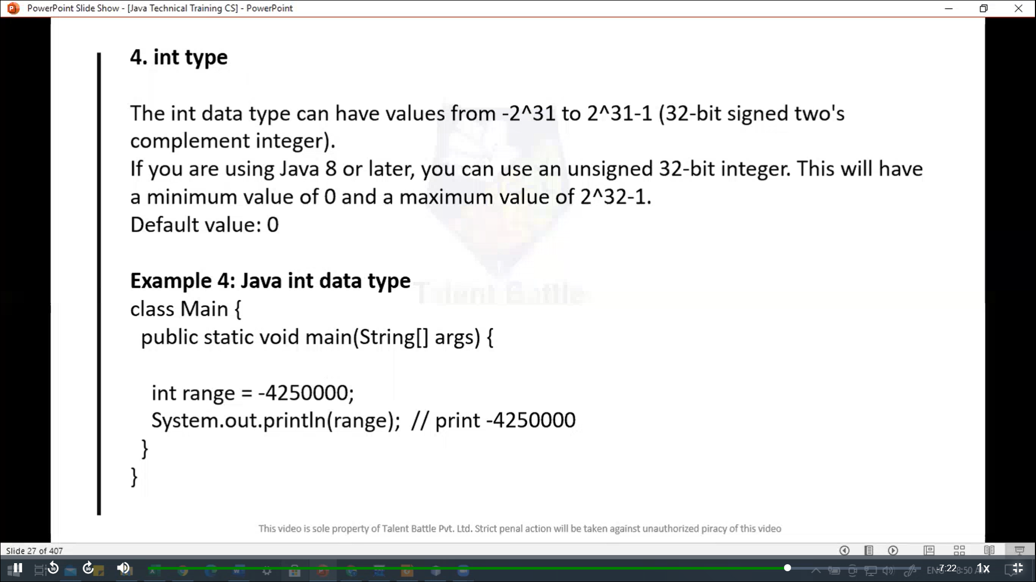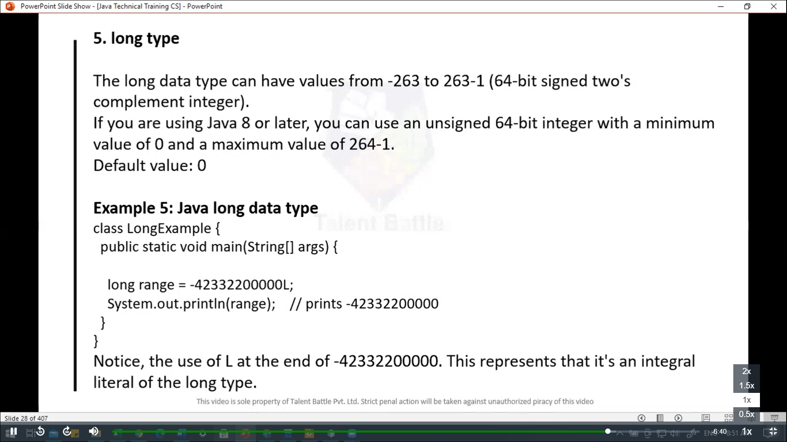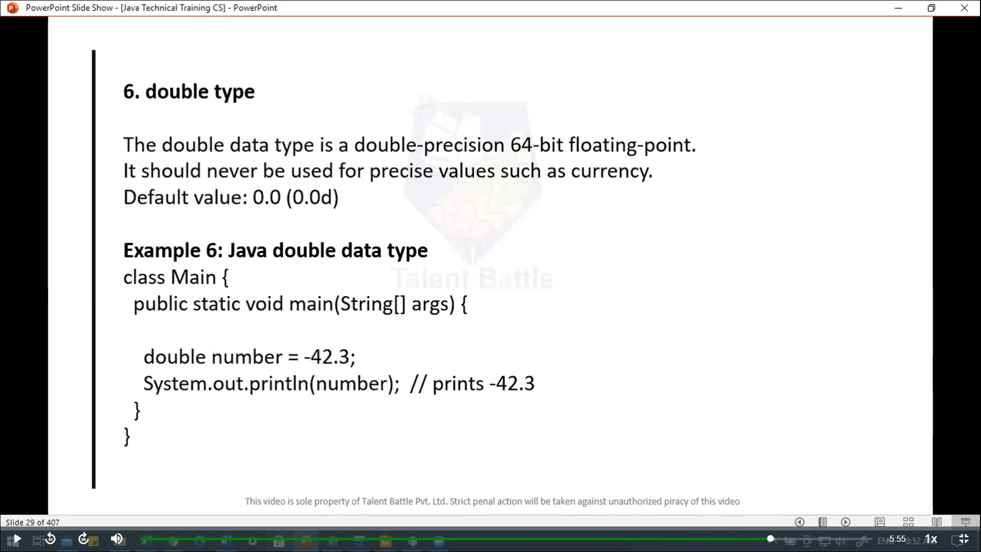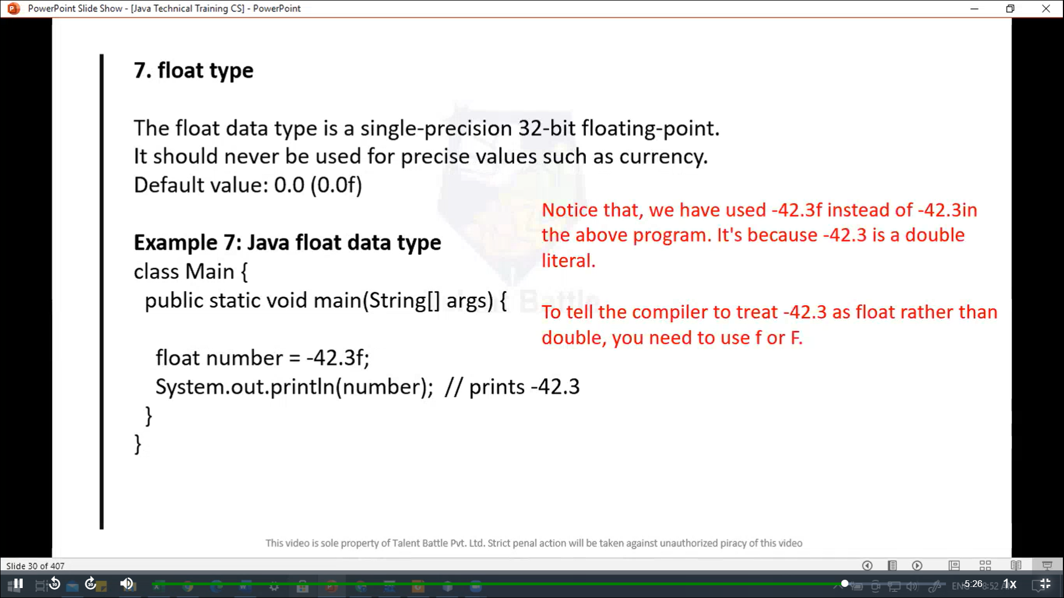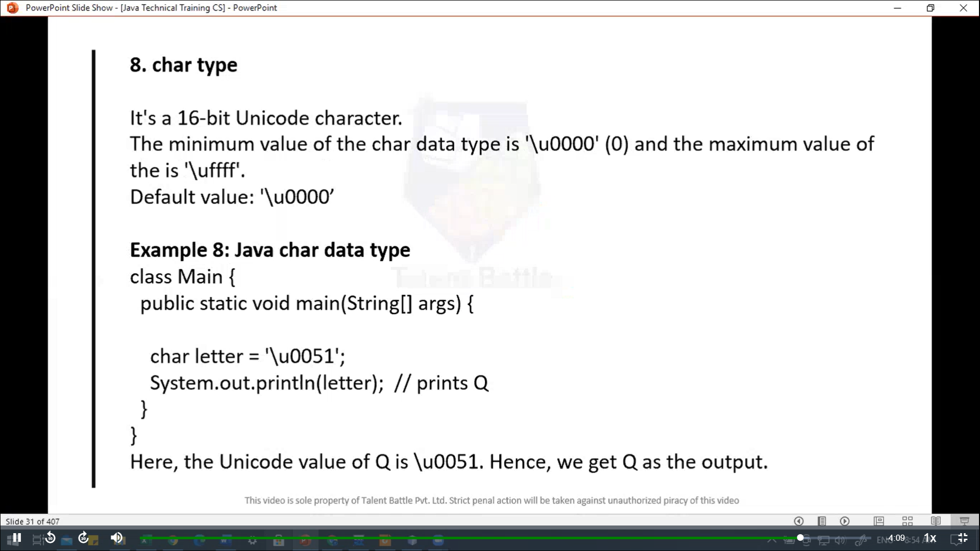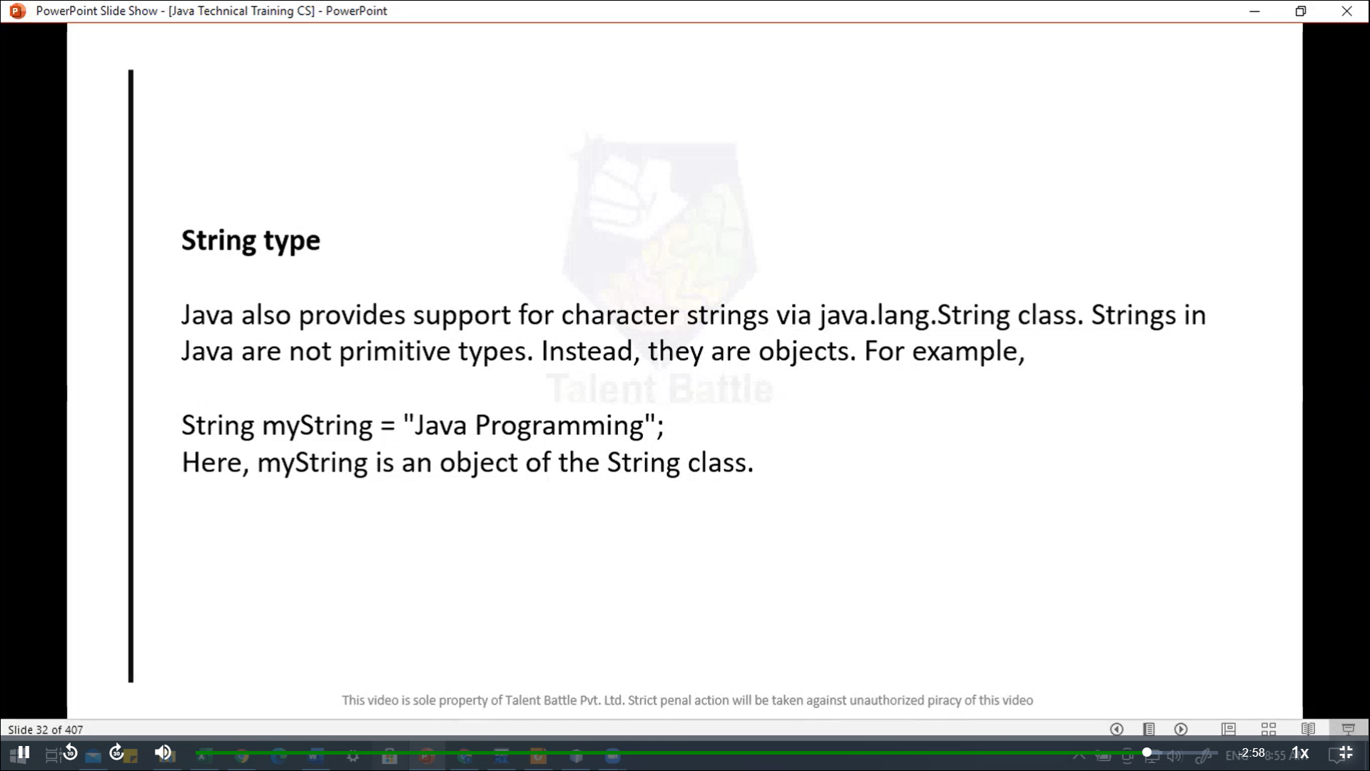

public class main {

  public static void *main*(String[] ***args***){

    /*

    double myDouble = 3.4;

    float myFloat = 3.4F;

    // 3.445 * 10^2

    double myDoubleScientific = 3.44e2;

    System.out.println(myDouble); // prints 3.4

    System.out.println(myFloat); // prints 3.4

    System.out.println(myDoubleScientific); // 344.0

   */

   // boolean type

   boolean flag = **true*;***

   System***.***out***.****println*(flag)***;*** // print true

   // byte type

   byte myByte = 123***;***

   System***.***out***.****println*(myByte)***;*** // prints 123

   // short type

   short temperature = -200***;***

   System***.***out***.****println*(temperature)***;*** // -200

   // int type

   int myInt = 1234567890***;***

   System***.***out***.****println*(myInt)***;*** //1234567890

   // long type

   long myLong = 1234567890123L***;***

   System***.***out***.****println*(myLong)***;*** // 1234567890123

   // double type

   double myDouble = 3.4***;***

  System***.***out***.****println*(myDouble)***;*** // 3.4

  // float type

  float myFloat = 3.4F***;***

  System***.***out***.****println*(myFloat)***;*** // 3.4

  // char type

  char myChar = 'A'***;***

  char myChar1 = '**\u**0051'***;***

  System***.***out***.****println*(myChar)***;*** // A

  System***.***out***.****println*(myChar1)***;*** // Q

  }

}

// Java Hello World Program

// Your first program

class HelloWorld {

  public static void *main*(String[] ***args***){

    System***.***out***.****println*("Hello, World!")***;***

  }

}